Assignment 1
Step 3 – Knowing my company & Annual Report KCQ’s

Website
Annual Reports
Knowing my firm – Background info, what they do, challenges & opportunities
My company is Clover Corporation and my initial reactions were surprised and intrigued as Clover Corp is in Healthcare industry. My reaction was reflecting on the current crisis the world is facing due to Covid-19. After visiting Clover Corp’s website I was happy to learn that I had received an Australian company compared to unit 11059, where my company was based in the United Kingdom.
Clover Corp started off as family owned business founded by Hamish Drummond, who’s visions were to be able to improve people’s health with the Omega-3 fatty acid. Today, this vision is still partly focused on in the way of delivering stable omega-3 and omega-6 products to the medical food market and also into infant nutrition. Clover Corp are the global leader in delivering and improving infant human health through stable micronutrients.

One of the technologies Clover Corp utilises is called microencapsulation. Microencapsulation is a process where individual particles from active agents are stored within a shell, which is then surrounded or coated by a film of polymeric material. These particles can then be later released by a micrometre or millimetre measure. A benefit from the microencapsulation process is that it protects sensitive oils from oxidation. This particular technology is used to add nutritional oils such as fish, tuna, fungal and algal oils to infant formula, beverages and foods.
Clover Corp believes in optimal nutrition and with this they have a philosophy to provide products which come from a healthy source. To do this, the fish which is used in their fish oil products is wild-caught responsibly using only dolphin-safe catch methods.
I found it quite difficult to find any news articles or information about my firm from sources outside of their own website. Their website did contain this research paper about whether microencapsulated tuna oil could be absorbed at higher rate compared to fish oil. There was also this study to determine if taking omega-3 DHA during pregnancy would boost a child’s cognition and language skills.
I believe my firm has a very big opportunity here in Australia as I was not able to find any other Australian companies providing the products and services to help create more nutritional products using omega-3 and omega-6 products. Yes, they are many companies who create products like vitamins we can buy off the shelf, however Clover Corp provides the key ingredients to go into everyday food and beverages as well as into vitamin supplements. The other side to this as a challenge would be finding customers who are seeking out to create products with the need of this nutritional benefit.
Annual Report KCQ’s
Moving onto Clover Corp’s latest annual report I first noted a few, what I seen as, ‘red flag’ items, listed in chairman’s statement. My first ‘red flag’ was in relation to an increase in business development activities, Clover Corp now have staff located in New Zealand, Europe and China. Due to this increase in human resources they have stated that their operating expenses increased by $2.3m compared to 2018. A debt position of $13.5m is also mentioned, reflecting from the loan facility established to invest in Melody Dairies and to purchase an Australian manufacturing site. Hopefully an increase in profit is shown in the financials from these investments.
Reading on through the director’s report it is stated that Clover Corp has 42 employees, up by 2 employees compared to 2018. This seems like a very small employee base to me, and thinking back to the fact Clover Corp employed more people in other countries over 2019, Clover Corp really doesn’t seem to be a very big corporation but that their employees must take quite large wages since they state the $2.8m increase in operating expenses is due to staff increases? I am not sure if I am understanding this part correctly.
Moving onto the financial statements I started with the Income Statement. Overall profit increased by $2.6m although an initial glance showed revenue increasing by a staggering $14m compared to 2018, unfortunately it seems Clover Corp’s expenses, primarily raw materials, consumables & conversion costs ate up most of this increase in revenue. However, comparing by percentage of how much revenue was consumed by raw materials, consumables & conversion costs, 2018 was actually larger at 71.02% and 2019 was 68.81%, so they appear to have decreased their cost of sales whilst also bringing in more income.
On the balance sheet I noted a very large increase in assets, in both current and non-current assets. As mentioned previously, Clover Corp invested into Melody Dairies which is valued at $10.461m. I noticed there were no investments in associates the prior year, this was also the case in 2017. It appears this $10.461m investment may perhaps be there first associate investment in a few years. The financial statements notes do mention that the investment objective is to be able to expand Clover Corp’s capacity to deliver more products to the market. Perhaps this will bring an even bigger surge in revenue for Clover Corp since they will be able to meet higher demands if the opportunity presented itself.
Inventories was the other most notable increase in assets. Increasing by $7.9m. Looking into the financial notes I do see a potential problem with inventory as Clover Corp is holding $13.2m in finished goods, slightly more than the raw materials value they are holding at $13.1m. I would expect their days of inventory ratio to be quite high. Perhaps they are manufacturing too much product compared to the sales they are making.
Total liabilities have more than doubled in 2019 ($29.6m) compared to 2018 ($13.m). Interest bearing liabilities appear to be the biggest factor in this increase. This liability is the flip side to the investment in Melody Dairies. This investment was funded by a loan and is secured by a first mortgage over the investment itself, land, buildings and a general charge over the Group’s assets. Although Clover Corp’s liabilities have increased greatly there assets still outweigh there liabilities, which is very good.
Discussions & reflections
At this stage, the main concern I have for my company is the amount of inventory they are carrying. I assume their product has expiry dates, as it is food, therefore I believe there is a possible risk of a lot of product wastage.
This time around reading financials I didn’t find anything too difficult to understand apart from the staff increase and wages costs. I believe this is because I was not as overwhelmed compared to reading my firms annual report in unit 11059. Also I have learnt reading the notes to the financials really does explain a lot more if you actually take the time to read them (if you need to).
As stated earlier I am happy with the company I have been given as they are based in Australia. However finding information (outside of their website) about them proved more difficult compared to my company from unit 11059. Comparing Clover Corp’s financials to the firm I had in unit 11059, I found them much easier to read. I believe this is due to having some experience gained from the last unit and also the fact the Clover Corp’s financials are over two thirds smaller than my last company. The layout of Clovers Corp’s financials are very similar to my previous company, this was also a great help when reading through the financials.
I posted some of my company info on my blog, the forums and Facebook in an attempt to discuss with others about our firms but didn’t have much luck with responses. So I decided to skim over other students firms annual reports that were in the Healthcare Industry like my firm. I looked at Aveo Healthcare (retirement village operator) and Avita Medical (skin regeneration clinic). Aveo Healthcare’s financials were very similar in layout to my company and looked a lot like my firms financials from unit 11059. Avita Medical was just black and white, not very inviting for an investor in my eyes. However their financials layout was easy to read and they also included every digit in their listed figures, they don’t state $m or $’000 on the header of each column. I think this is a more precise way of presenting financials.
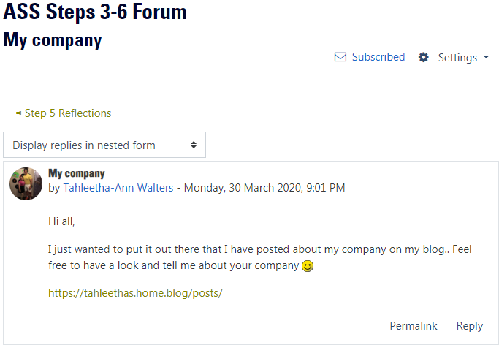
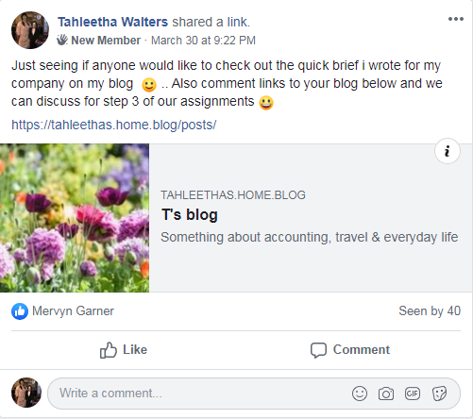

Step 4 –Practising the recording process & KCQ’s

Excel spreadsheet - Uploaded to Moodle
I was quite looking forward to completing this step as I enjoy using excel. I was also interested to see if my budget was being somewhat adhered to. I had quite a lot of transactions spanning over a one-month period so I decided to use a two week timeframe instead.
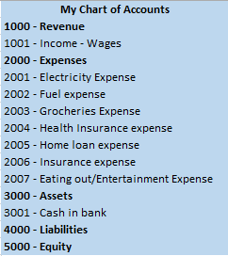
I knew I would have multiple expense accounts in my chart of accounts because I wanted to see clarity between each expense and not lump them all into broad categories. For example separating groceries from takeout/eating out food.
I found it easiest to export my transactions and then sort them by description (within excel). I didn’t have access to a printer to print and then manually assign each transaction a category, however I think doing the sorting process through excel was a quicker and more simplified way (for me).
Completing the income statement was a breeze, as we did quite a bit of linking in unit 11059.
Creating my own balance sheet would be interesting to do, as we could then see our overall position, in life I guess. Perhaps I could include super balances and loans. Completing a balance sheet would also bring to light what value we do have assets, which is good to know as generally from experience this is a question asked when going for large loans.
My chart of accounts differed to the study guide. I chose to use four numbers for my accounts as I found it easier to read. I also think my chart of accounts drove into a bit more detail then the study guide, for example as mentioned earlier, I wanted more clarity on what my money was being spent on so I separated food expenses. I also separate my two insurances, health and home from eachother to give more transparency.
By completing this task I did gain some insights about how much money we (my partner and I) spend on groceries each fortnight. Our grocery expense is almost as much as our house repayments, so I think we will need to look at this. This has been a useful exercise I must say and I think I would like to complete it for a longer period of transactions so that I can more visually see what we are spending our money on.
Amongst my transactions I found that the health insurance payment could have the accrual accounting basis applied as this is an advance payment because it covers the next two weeks of health insurance costs. The payment was made on the 20/03/2020 therefore it is covering the period of 20/03/2020 to 03/04/2020. This period includes days from two different months, March and April. To show accurately how much the expense of health insurance was for March, the April portion of the payment from 20/03/2020 would need to be ‘set aside’ to an asset account, perhaps called prepaid health insurance.
For example:
$191.05 / 14 days (a fortnight) = $13.65 per day
$13.65 * 3 days (amount of days relating to April) = $40.95
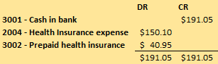

Note: As per the ATO, health insurance policies are exclusive of GST.

Step 5 – Creation of Trial Balance spreadsheet

Excel spreadsheet - Uploaded to Moodle
The task of creating the trial balance I found to be very stress-free. Data entry is something I delight in doing. As always Maria’s videos are most helpful when completing parts of the assessments which include the using of excel.
When completing the final balancing of the trial balance I found that my profit was closed to retained profits and as well as the foreign currency translation reserve.

Step 6 – Providing & Receiving Feedback

PEER FEEDBACK SHEET: Assignment Steps 3-5 Feedback From: Tahleetha Walters
Feedback To: Eloise Bourne .

 | My Comments
Step 3 | Including some links to news articles or reports about your company would be good. I think you have provided a substantial amount of comments and KCQ’s about your understandings (and confusions) to points of the annual report. Did you have any discussions with other students you can include in this step?
Background information on company
Comments/KCQs
Discussion with others
Step 4  The recording process | I think you have provided a good level of feedback and thoughts for this step. My only suggestion would be to link your income statement to your transaction lists – this serves as a triple check that everything is calculating correctly.
Step 5 | I suggest a way to spilt your Foreign Currency translation amount correctly across the Accumulated losses and Reserves accounts could be by including a percentage calculation in your formula – for example =A22+(C56*50.06%) . The cells in my example are not for your spreadsheet but I believe this would work and ensure the entries are correct. You have written a very good reflection for this step.
Trial balance Discussion
Overall | Overall I think you are very much on track!

Note: Please use this sheet as a guide. There is no need to provide feedback on each step of the Assignment. For example, someone may have little or no draft work completed for one or more of the steps prior to asking for your feedback.

